Calculator Free
Linear and Quadratic Functions and Equations

Time: 45 minutes
Total Marks: 45
Your Score: / 45



Question One: [2, 2, 4 = 8 marks]
Consider the following Cartesian points (-2, 5) and (1,11)
- Determine the equation of the line passing through these two points.

- Determine the equation of a line perpendicular to the line found in part (a) and passing through the point (-6, 4)

- The line segment consisting of endpoints (a,b) and (1,11) has a midpoint of (-2, 5).
- Determine the values of a and b .

- Hence or otherwise determine the equation of the line parallel to the line in part (b) and passing through the point (a,b)

Question Two: [2, 2, 2, 2, 3, 3, 3, 3, 3 = 23 marks]
Solve each of the following equations, showing all algebraic working.
(a)

(b)

(c)

(d)

(e)

(f)

(g)

(h)

(i)

Question Three: [3, 2 = 5 marks]
- Sketch the lines and on the axes below.
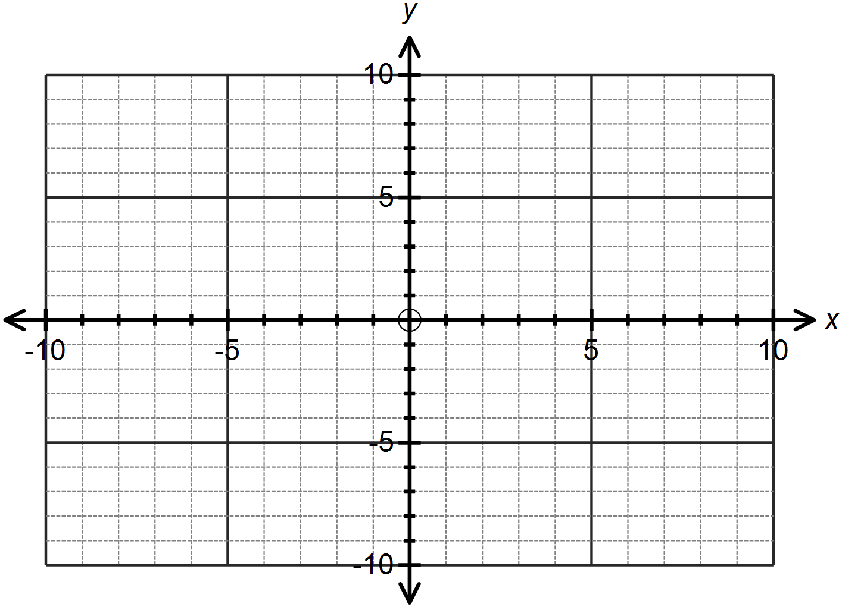

- 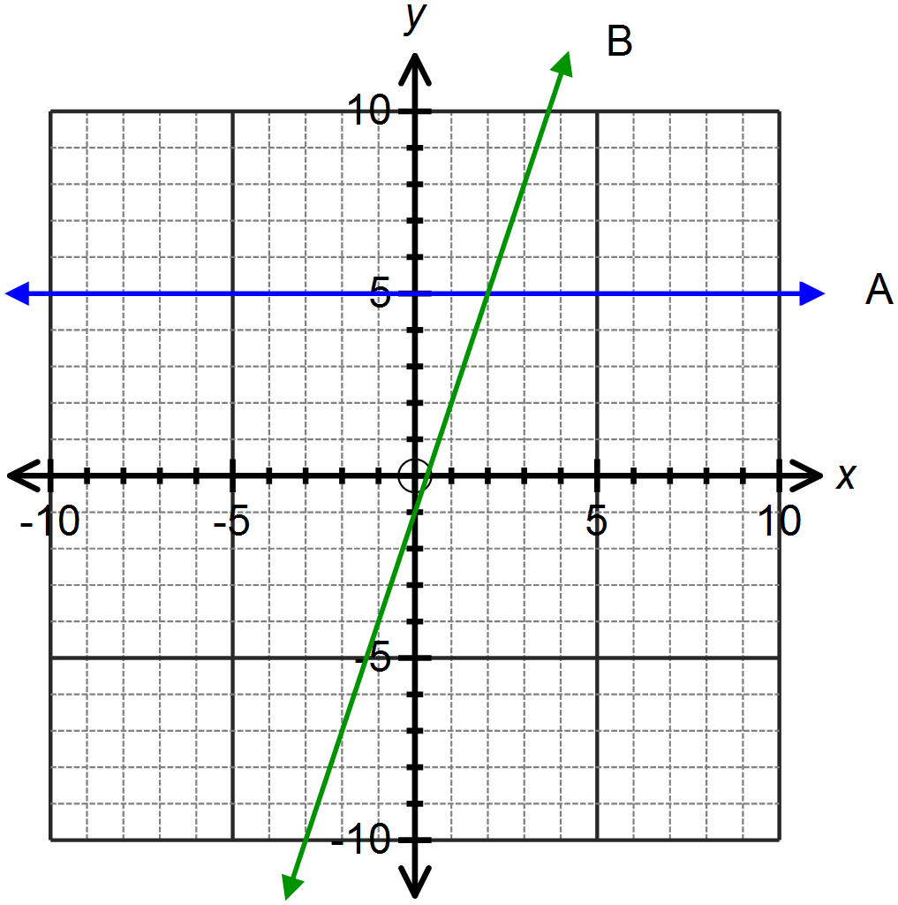Determine the equations of the lines graphed below.

A:

B:

Question Four: [1, 2, 1, 1, 2, 2 = 9 marks]
Consider the quadratic function
- State the coordinates of the y-intercept.

- Determine the coordinates of the x-intercept(s).

- By completing the square, transform the equation of the function into the form

- Hence or otherwise determine the equation of the line of symmetry.

- State the turning point for this function and its nature.

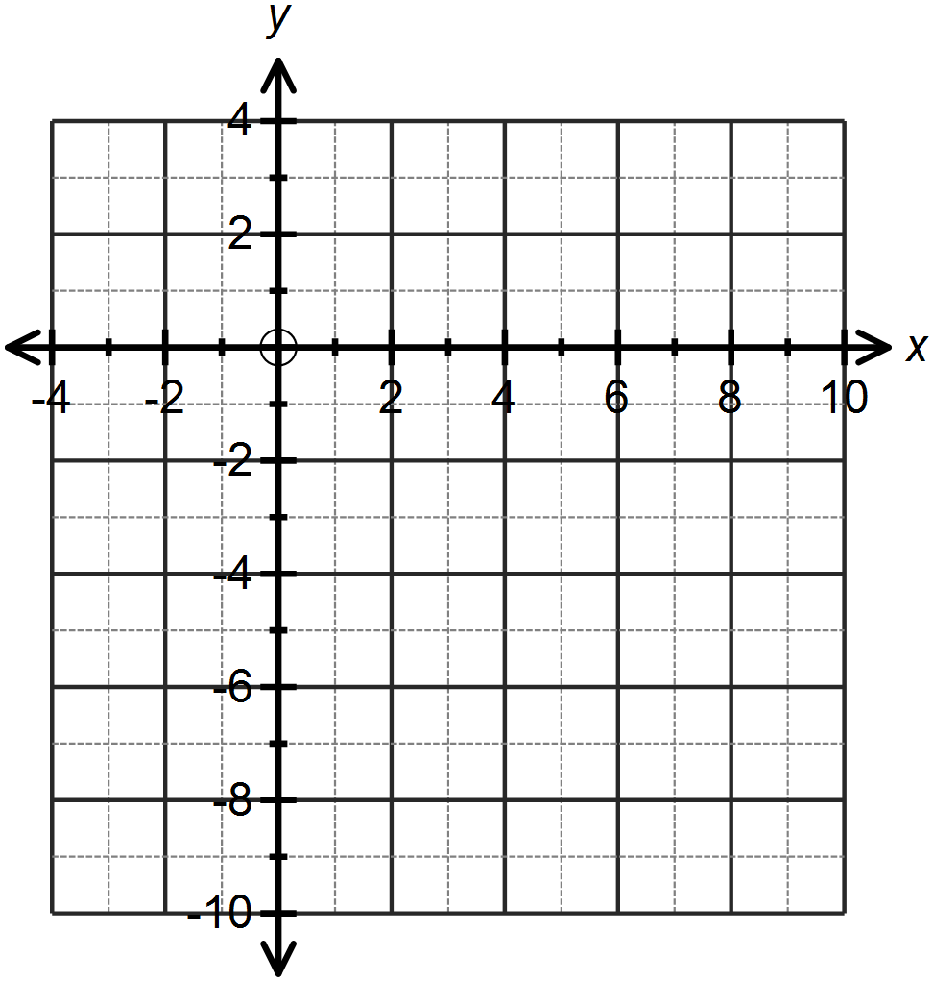
- Sketch this function on the axes provided.

SOLUTIONS
Calculator Free
Linear and Quadratic Functions and Equations

Time: 45 minutes
Total Marks: 45
Your Score: / 45



Question One: [2, 2, 4 = 8 marks]
Consider the following Cartesian points (-2, 5) and (1,11)
- Determine the equation of the line passing through these two points.


- Determine the equation of a line perpendicular to the line found in part (a) and passing through the point (-6, 4)


- The line segment consisting of endpoints (a,b) and (1,11) has a midpoint of (-2, 5).
- Determine the values of a and b .



- Hence or otherwise determine the equation of the line parallel to the line in part (b) and passing through the point (a,b)

Question Two: [2, 2, 2, 2, 3, 3, 3, 3, 3 = 23 marks]
Solve each of the following equations, showing all algebraic working.

(a)


(b)




(c)


(d)



(e)



(f)



(g)



(h)




(i)


Question Three: [3, 2 = 5 marks]
- Sketch the lines and on the axes below.

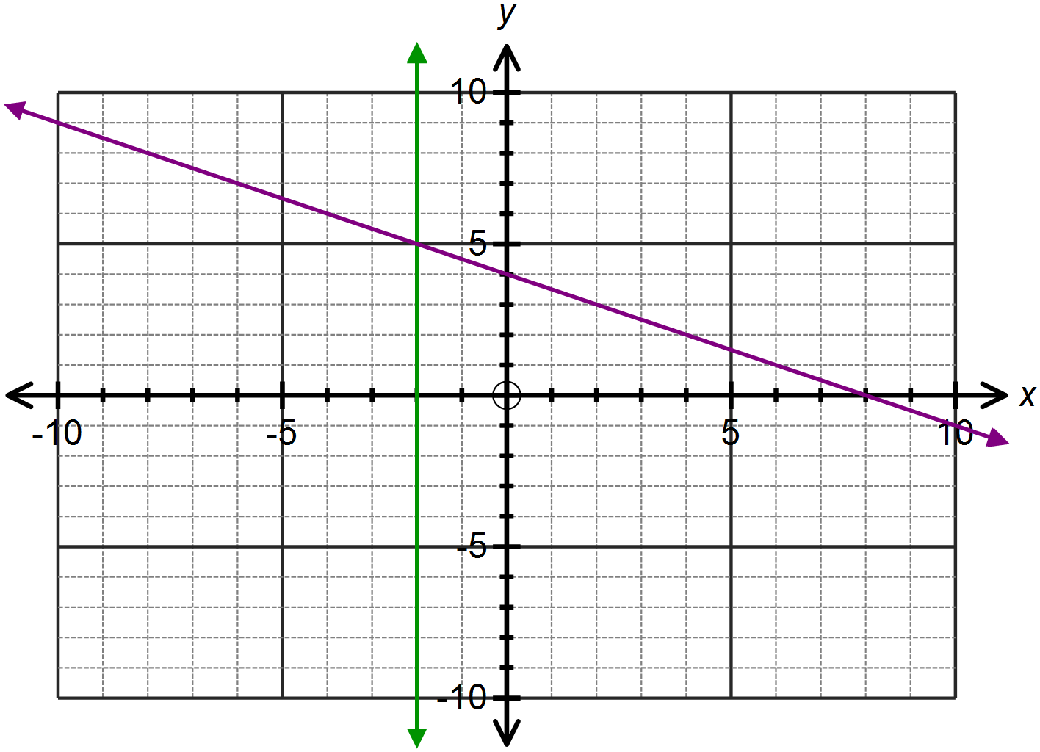





- Determine the equations of the lines graphed below.


A:


B:

Question Four: [1, 2, 1, 1, 2, 2 = 9 marks]
Consider the quadratic function

- State the coordinates of the y-intercept.


- Determine the coordinates of the x-intercept(s).



- By completing the square, transform the equation of the function into the form


- Hence or otherwise determine the equation of the line of symmetry.


- State the turning point for this function and its nature.



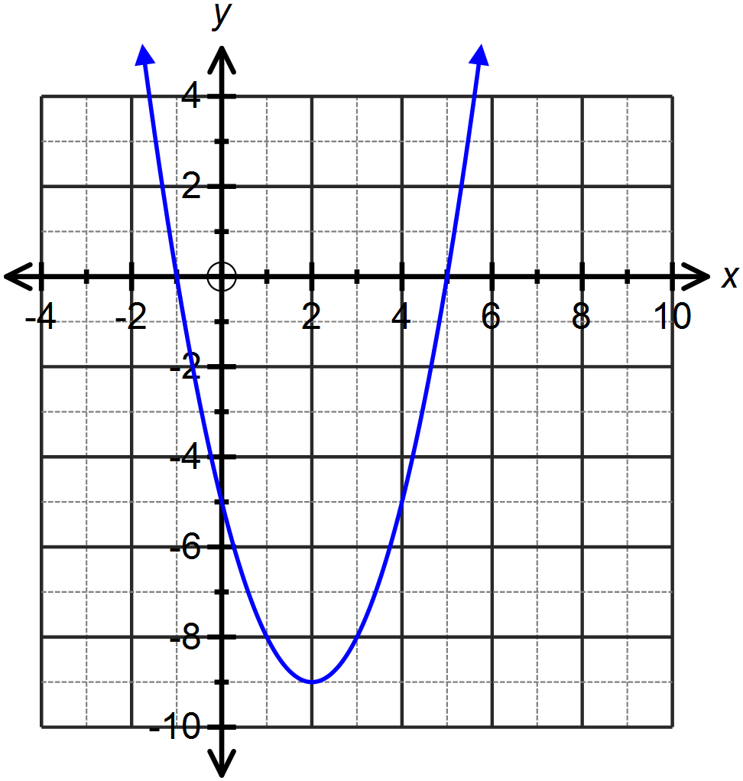
- Sketch this function on the axes provided.

